Introduction to Kinematics
  - The purpose of this activity is to give you an overview and an introduction of what we will be learning about kinematics over the course of the next month.

Part 1 – Bozeman Science Video

Go to the class website (www.scienceatcchs.weebly.com) and go to the “PowerPoints” page under “Physics” and watch the “Scalars and Vectors” Bozeman Science video.

Based on the information provided in the video, answer the following questions.

- Explain the difference between scalars and vectors.

- Explain the difference between speed and velocity.

- Explain why vectors are important when doing calculations in physics.

- Provide 3 examples of scalar quantities and 3 examples of vector quantities.

Part 2 – Physics Classroom Website

Go to the following address to complete this worksheet: http://www.physicsclassroom.com/Physics-Tutorial/1-D-Kinematics

Read through parts a to e in “Lesson 1: Describing Motion with Words” and complete the questions below.

Definitions
  - Kinematics
  - Scalar
  - Vector
  - Distance
  - Displacement
  - Speed
  - Velocity
  - Instantaneous speed
  - Average speed
  - Acceleration

Formulas & units

AVERAGE SPEED

AVERAGE VELOCITY

AVERAGE ACCELERATION

Check your understanding
- Scalars & Vectors

To test your understanding of this distinction, consider the following quantities listed below. Categorize each quantity as being either a vector or a scalar.

Quantity | Category
a. 5 m
b. 30 m/sec, East | \
c. 5 mi., North | \
d. 20 degrees Celsius | \
e. 256 bytes | \
f. 4000 Calories | \

- Distance & Displacement
  - Use the diagram to determine the resulting displacement and the distance traveled by the skier during these three minutes.
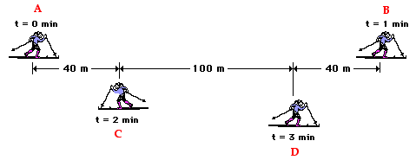

Distance: Displacement:

  - What is the coach's resulting displacement and distance of travel?
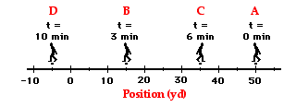

Distance: Displacement:

  - What is the distance and the displacement of the race car drivers in the Indy 500?

Distance: Displacement:

- Speed & Velocity
  - Use the diagram to determine the average speed and the average velocity of the skier during these three minutes.

Speed: Velocity:

  - What is the coach's average speed and average velocity?

Speed: Velocity:

- Acceleration

To test your understanding of the concept of acceleration, consider the following problems and the corresponding solutions. Use the equation for acceleration to determine the acceleration for the following two motions.

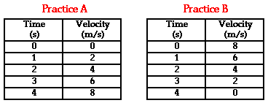

Practice A: Practice B:

Practice

- Which of the following statements about vectors and scalars are TRUE?
  - A vector is a large quantity and a scalar is a small quantity.
  - A scalar quantity has a magnitude and a vector quantity does not.
  - A vector quantity is described with a direction and a scalar is not.
  - Scalar quantities are path dependent quantities and vector quantities are not.
  - The quantity 20 m/s, north is a speed and as such is a scalar quantity.
  - The quantity 9.8 m/s/s is an acceleration value and as such is a vector quantity.

- Which of the following statements about distance and displacement are TRUE?
  - Distance is a vector quantity and displacement is a scalar quantity.
  - A person makes a round-trip journey, finishing where she started. The displacement for the trip is 0 and the distance is some nonzero value.
  - A person starts at position A and finishes at position B. The distance for the trip is the length of the segment measured from A to B.
  - If a person walks in a straight line and never changes direction, then the distance and the displacement will have exactly the same magnitude.
  - The phrase "20 mi, northwest" likely describes the distance for a motion.

- Which of the following statements about velocity and/or speed are TRUE?
  - Velocity is a vector quantity and speed is a scalar quantity.
  - Both speed and velocity refer to how fast an object is moving.
  - Person X moves from location A to location B in 5 seconds. Person Y moves between the same two locations in 10 seconds. Person Y is moving with twice the speed as person X.
  - The velocity of an object refers to the rate at which the object's position changes.
  - For any given motion, it is possible that an object could move very fast yet have an abnormally small velocity.
  - The phrase "30 mi/hr, west" likely refers to a scalar quantity.
  - The average velocity of an object on a round-trip journey would be 0.
  - The direction of the velocity vector is dependent upon two factors: the direction the object is moving and whether the object is speeding up or slowing down.

